Worksheet 3.3

Geological time
Answers

The geological eras
1. (a) Complete the following table by naming the geological eras. The times for each era are approximate and vary as new data and evidence is collected.
Time (millions of years ago) | 0–65 | 65–245 | 245–545 | 545–2500 | 2500+
Era | Cainozoic | Mesozoic | Palaeozoic | Proterozoic | Archaeozoic
(b) Identify the era in which each of the following events occurred (as revealed by the fossil record).
First birds appear | Mesozoic | Land plants emerge | Palaeozoic
Bacteria first appear | Archaeozoic | Humans appear | Cainozoic
Oxygen-rich atmosphere forms | Proterozoic | Insects appear | Palaeozoic

Fossils and geological time
2. The following sea cliff face has four sedimentary layers that have been dated.
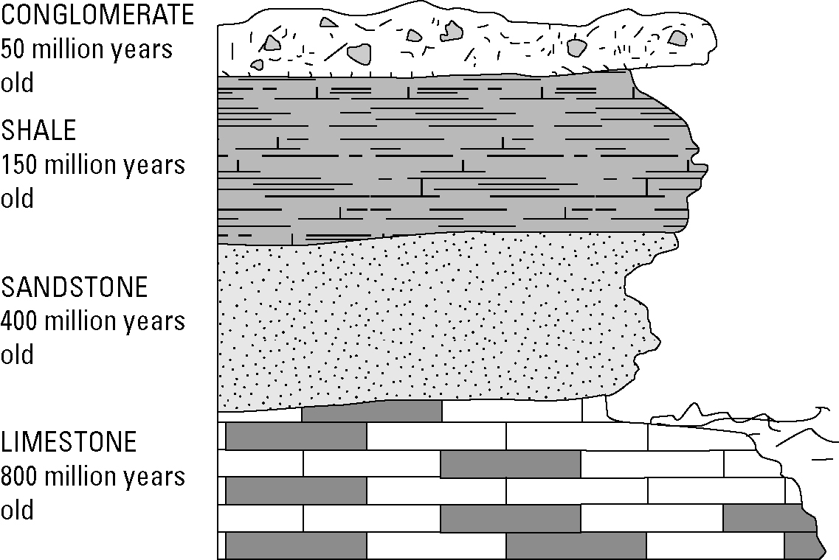

(a) Algal fossils were found in the limestone layer. In which era did these organisms live?
Proterozoic era

(b) Explain why a dinosaur fossil could not be found in the sandstone layer.
Dinosaurs did not dominate the land until the Mesozoic era. The sandstone layer is too old for such fossils.

(c) Identify which of the following fossils could only be found in the conglomerate layer: amphibians, seed plants, turtles, insects.
Seed plants. Seed plants did not evolve until the Mesozoic era. All the other layers are too old for seed plants.

Worksheet 3.3

Page 2

Continents and geological time
3. The following drawing shows the continents as they were 250 million years ago.
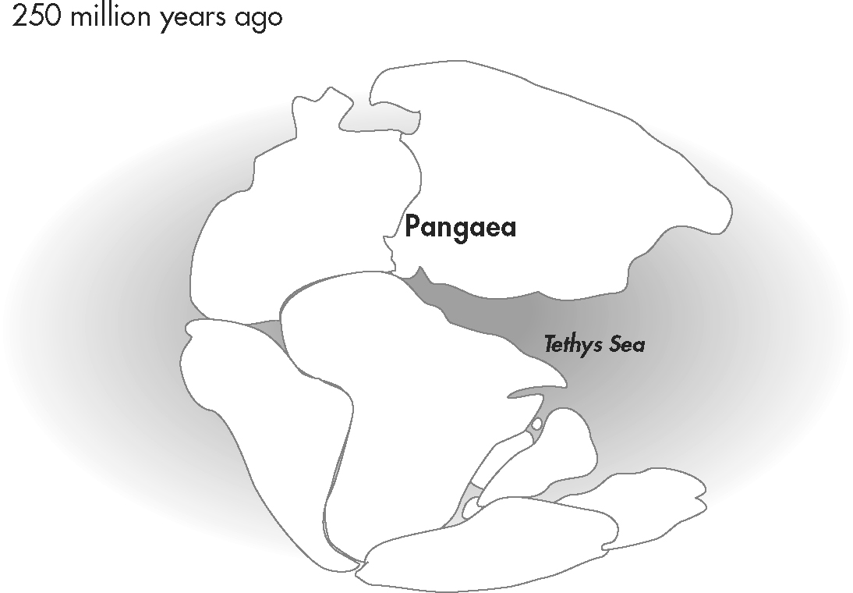
(a) The continents were in these positions at the end of which geological era?
Palaeozoic

(b) Describe the types of living things that dominated the temperate lands at that time.
Ferns were the dominant land plants and amphibians the dominant vertebrate land animals. Insects and worms were dominant invertebrates.

